# Aromy

USER DOCUMENTATION FOR AROMY V 0.2

## **Team OneTen**

11/10/2022

Cassandra Tong

**pton0008@student.monash.edu**

Client Liason

Shangqian Du

**sduu0007@student.monash.edu**

Developer

Daniel Phelan

**dphe0001@student.monash.edu**

Writer and Developer

Rui Qin

**rqin0002@student.monash.edu**

Developer

Eugene Aquino

**eaaqu1@student.monash.edu**

Technical Writer

# 

# TABLE OF CONTENTS

**Aromy** **0**

Team OneTen 0

**TABLE OF CONTENTS** **1**

**1.1 Purpose** **2**

**1.2 Scope** **2**

**2.1 Credentials** **3**

**2.2 Future Features** **3**

**2.3 User Journey Map (Flow Chart)** **5**

**2.4 Admin System** **6**

2.4.1 Customer Management 6

2.4.1.1 Provide the List of All Customers 6

2.4.1.2 Use View, Edit, Delete Functions 6

2.4.1.3 Add Customers 8

2.4.2 Orders Management 9

2.4.2.1 Provide the List of All Orders 9

2.4.2.2 Use View, Edit, Delete Functions 9

2.4.2.3 Add Orders 11

2.4.3 Products Management 12

2.4.3.1 Provide the List of All Products 12

2.4.3.2 Use View, Edit, Delete Functions 12

2.4.3.3 Add Product 14

2.4.4 Categories Management 14

2.4.4.1 Provide the List of All Categories 14

2.4.4.2 Use View, Edit, Delete Functions 15

2.4.4.3 Add Category 16

2.4.5 Enquiries Management 17

2.4.5.1 Provide the List of All Enquiries 17

2.4.5.2 Use View, Edit, Delete Functions 18

2.4.5.3 Add Enquiry 19

2.4.6 User Management 20

2.4.6.1 Provide the List of All Users 20

2.4.6.2 Use View, Edit, Delete Functions 21

2.4.6.3 Add User 22

1.0 Introduction

Aromy is an online business in the retail industry and a leading Australian supplier of aromy therapy based products and massage services for the aged care industry. They sell aromatherapy products to clients via their website—managing customers, orders, inventory and enquiries.

# 1.1 Purpose

The purpose of this User Documentation is to act as a manual and ensure that users of the system, present and future, have a resource and reference of non-obvious business processes to refer to when using their system.

# 1.2 Scope

This document is divided into two parts.

The first part introduces:

* The document’s purpose
* Credentials (including demo accounts and passwords)
* Future Features (including features under development and description of future plans)

The second part contains:

* The main functions of the system
* The sub functions of the main functionalities.

This part is intended to guide users through operation of the system and act as an ongoing reference/onboarding tool.

# 

2.0 System Feature

# 2.1 Credentials

Demo Administration account

Username: team110@aromy.com.au

Password: team110

# 2.2 Future Features

We plan to add greater functionality and several new features to the system in the future and these can be divided into the below categories.

**Full online store**

In the future, we would like to implement a full online store experience including a shopping cart. This would allow customers to add products to their cart, building their order on the front-end system, and then submit the entire cart (ie: order) for payment.

We would also like to implement prices and discounts. This would allow customers to more effectively calculate their order total for budgetary reasons. These would be visible both on the product page and in the cart with auto-calculations based on desired quantity. For discounts, this would involve both displaying a discounted price beside the struck-out regular price during sales periods and also allowing customers to enter discount codes at the cart to be applied to the entire order. We believe this would assist in driving sales as it would incentivise customers to purchase.

**Admin**

On the admin side, we would like to implement an automatic reorder system. This would check the current product stock levels against the alert levels and flag the admin or automatically generate a report when reordering is required. Implementing this would require the product entries to include a ‘reorder quantity’.

We would also like to include a stock location management system that can record the physical location of stock within Aromy’s headquarters or warehouse, for easy restocking and pick-packing.

In addition, we believe a receiving system would synergise well with the above proposed future features. This would allow incoming products (barcodes and quantities) to be imported on an ASN (Advanced Shipment Notice) and then scanned upon arrival with corresponding stock automatically added to the relevant product. Implementing this would require that all products are barcoded and that the barcodes are recorded under the product entry in the database.

Finally, to assist with outgoing orders, a dispatch process would be beneficial. This could be as complex as being able to generate dispatch waves based on different order qualities (eg: size, value, time placed) or as simple as a field in which a tracking number can be manually entered and automatically emailed to the customer.

# 2.3 User Journey Map (Flow Chart)

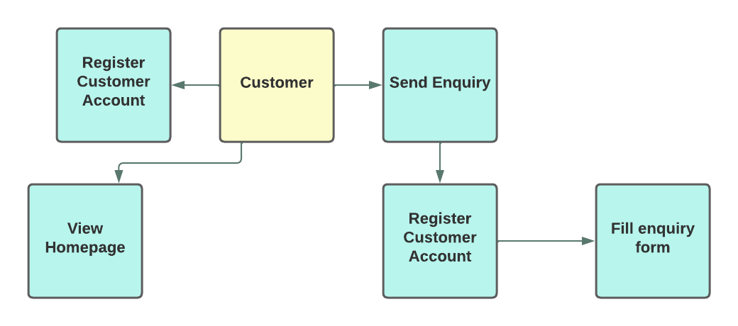

# 2.4 Admin System

This section details how to access and use the many elements of the new Aromy web application.

## 2.4.1 Customer Management

### 2.4.1.1 Provide the List of All Customers

Accessing the Customer list will enable a quick snapshot of current Aromy customers, to streamline communication and assist finding particular customers, if certain details might have been lost.

Clicking the “Customers” navigation bar on the left hand side provides the “List” option allowing you to view all customers recorded in the database.

From this view, a customers’ ID, Name, Address, and contact details are present. Each of these can be filtered to order by certain specification, if the administrator may need to narrow down customers by addresses, suburbs or postcodes. This would assist in finding customers grouped together if orders to a certain area were affected, making it easier to contact these people.

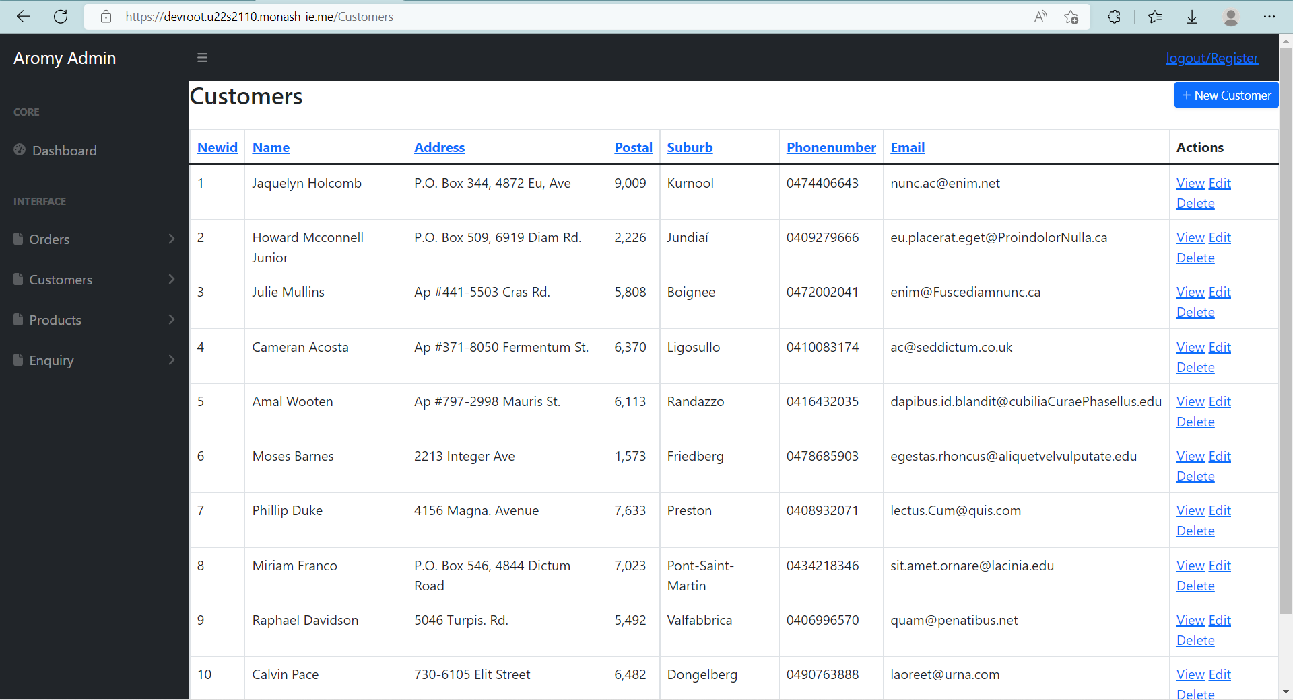

### 

### 

### 2.4.1.2 Use View, Edit, Delete Functions

From the **List** view under the **Customer** purview, the **View, Edit,** and **Delete** options are available.

If the administrator would like to look at a customer specifically, the admin can press the The **View** option to display all details recorded about the customer. If a customer requires their details to be amended or changed, such as update their address, The **Edit** options allows a user to edit any details about a customer except for their Customer ID.Finally, If a Customer contacts Aromy and requires their details to be deleted. The **Delete** option will prompt the user to ensure there is no misclick and after confirming a user will be able to delete the customer from the Database.

Similar View, Edit and Delete functionality occurs in the same manner throughout the rest of the Aromy Admin site.

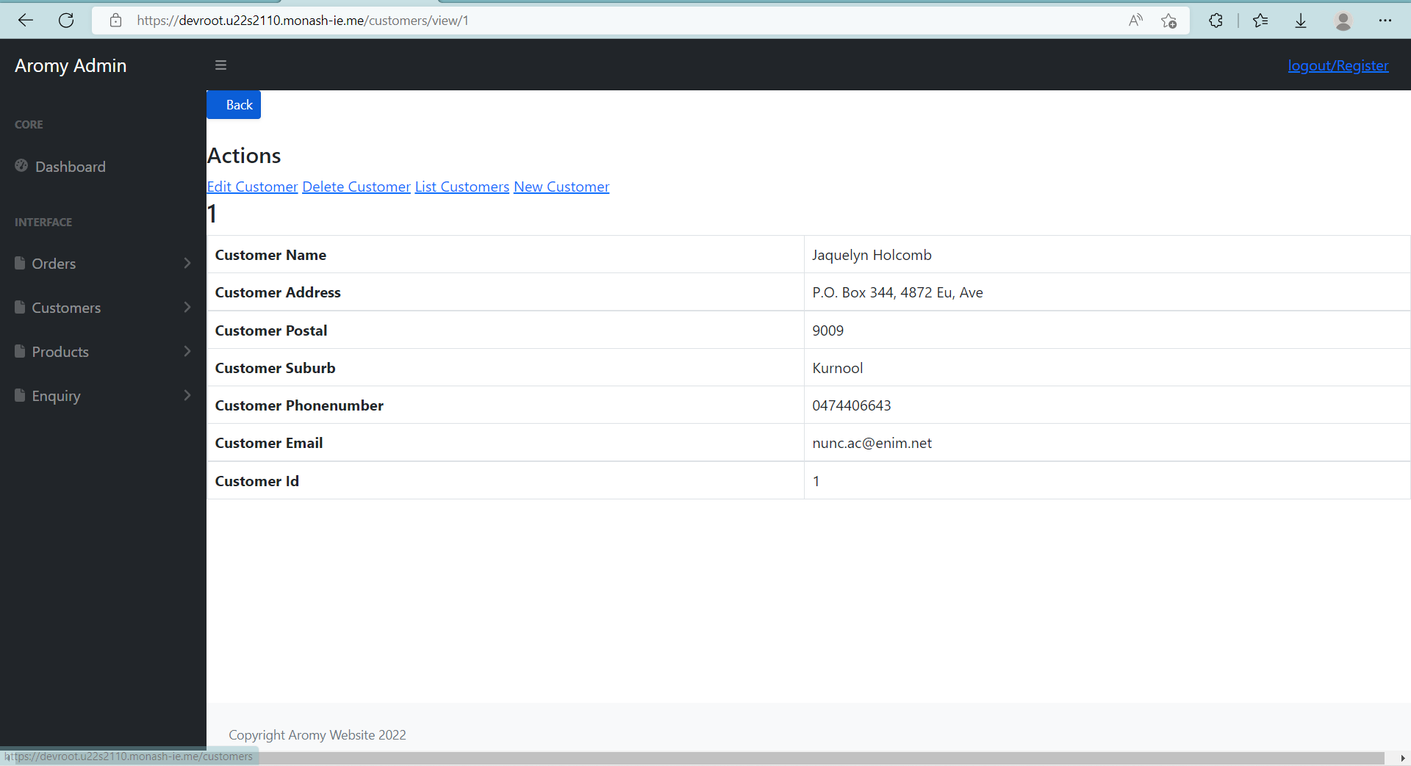

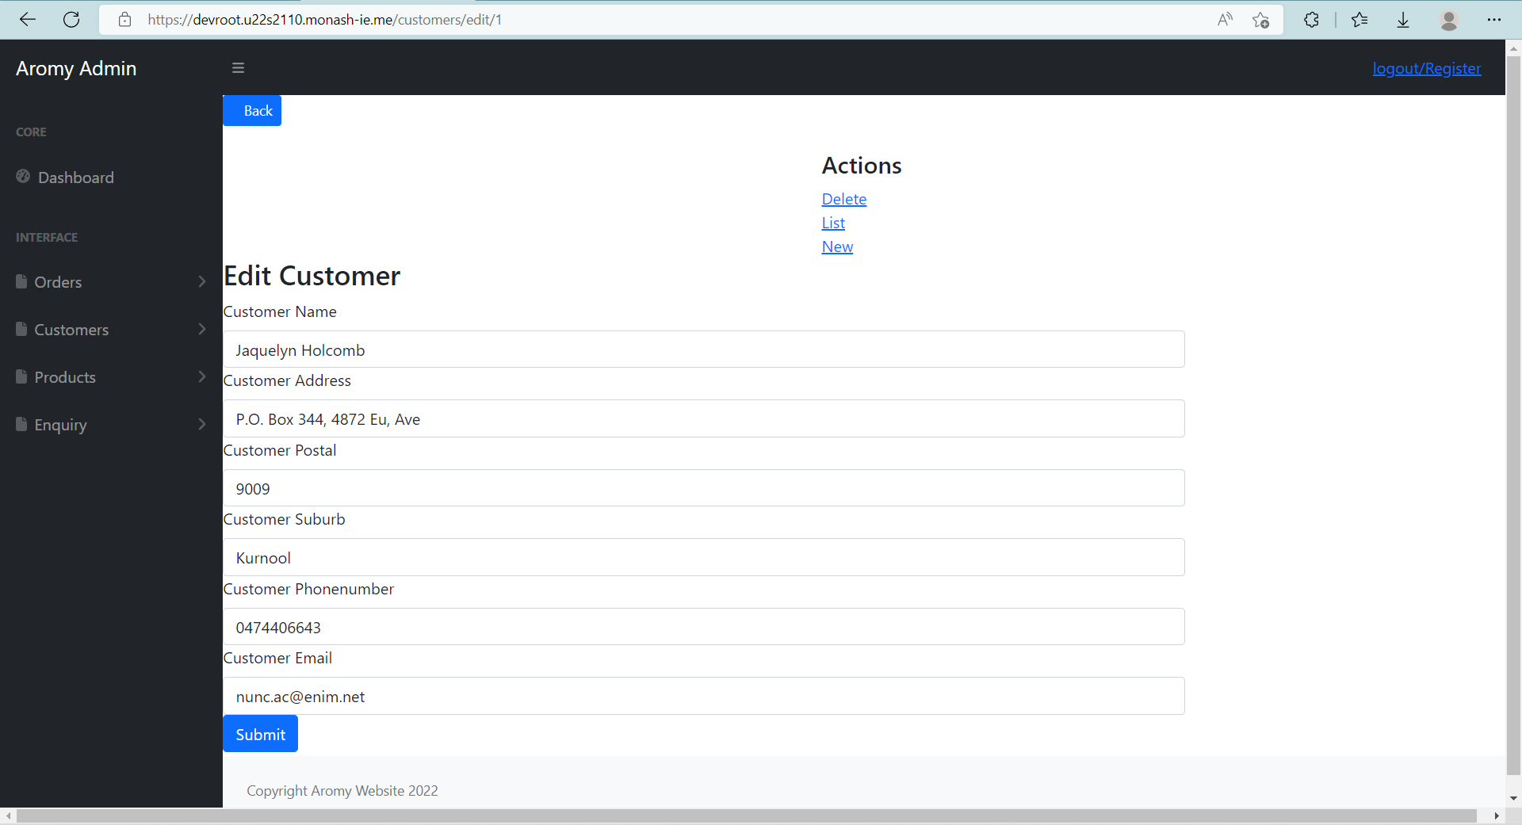

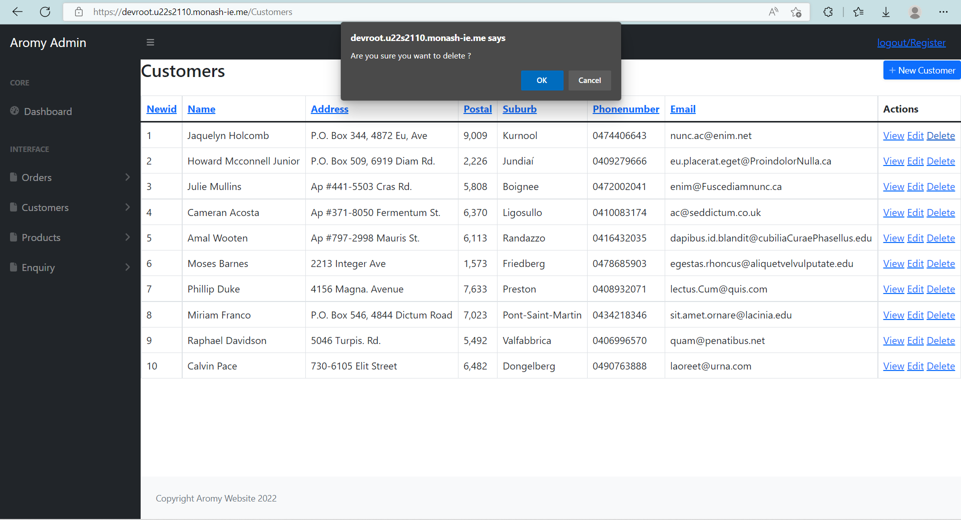

### 2.4.1.3 Add Customers

If someone presents themselves to aromy by directly contacting an Aromy staff member or sending an enquiry to set up an account. The administrator will be able to utilise the **List** option on the navigation bar set to the **New Customer** option that will send you to add a new customer directly into the database, granted that all the information is present. This option is also available as a button on the top right hand side of the **List** view for ease of access for the administrator. The administrator would need to ensure they add a customer name, address, postal address, suburb, phone number and email.

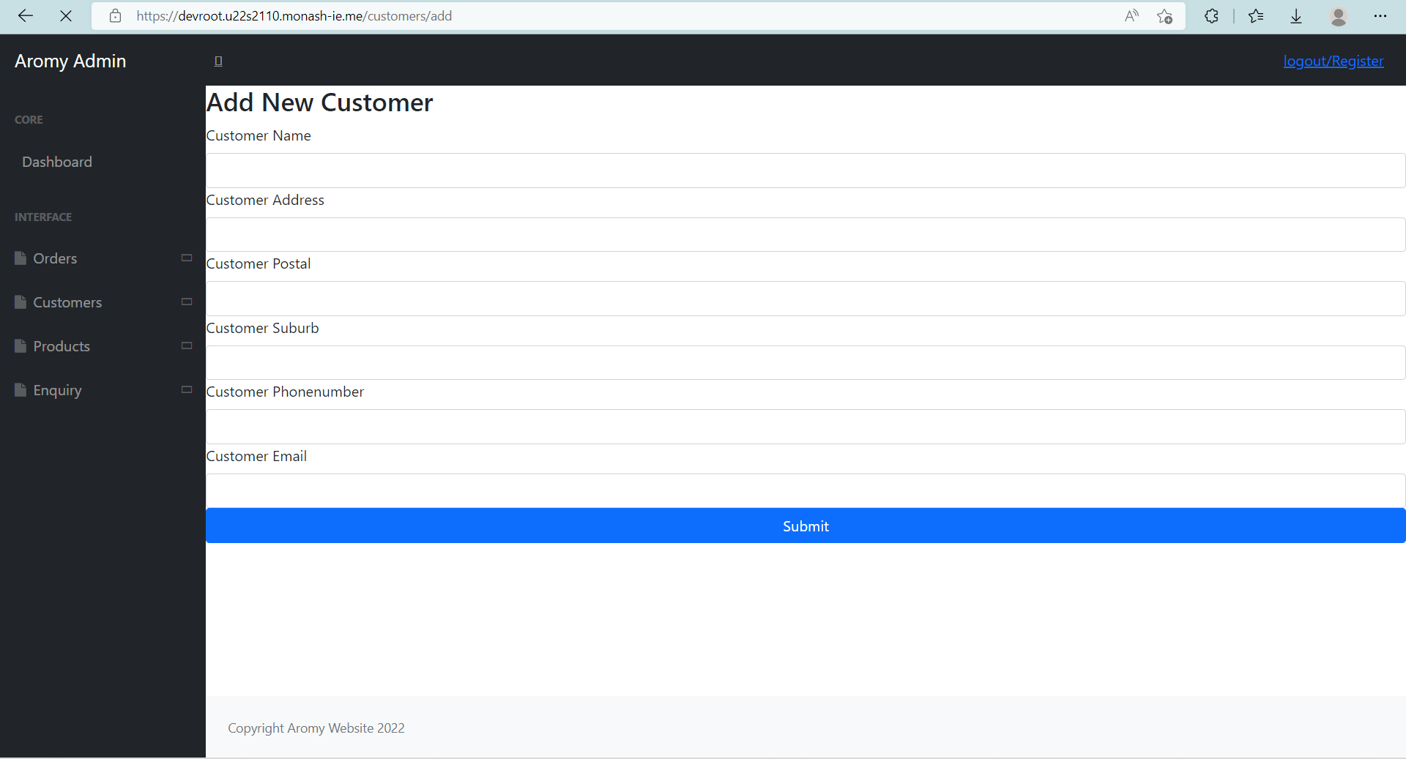

After the information has been filled in, clicking submit will add the customer into the database and thus will be included into the **List** view.

## 2.4.2 Orders Management

### 2.4.2.1 Provide the List of All Orders

If an administrator wanted to view a list of orders that have been created by Aromy staff, Clicking the “Orders” navigation bar on the left hand side provides the “List” option allowing you to view all orders recorded in the database.

From this view, the administrator will be presented with the order ID, Date, and relevant customer name in a list. If the administrator wanted to sort this table view, they would be able to sort each column.

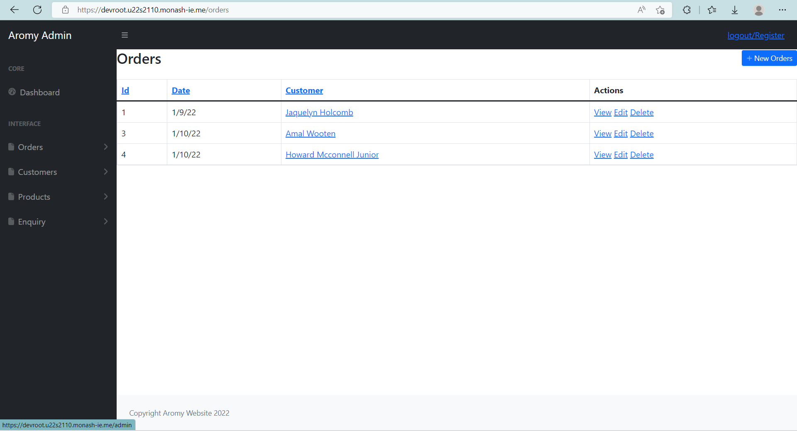

### 2.4.2.2 Use View, Edit, Delete Functions

From the **List** view under **Orders**, the **View, Edit,** and **Delete** options are available.

The **View** option displays all details on the category on their own page.

The **Edit** option allows a user to edit the category name.

Finally, the **Delete** option will prompt the user to ensure there is no misclick and after confirming a user will be able to delete the category from the Database

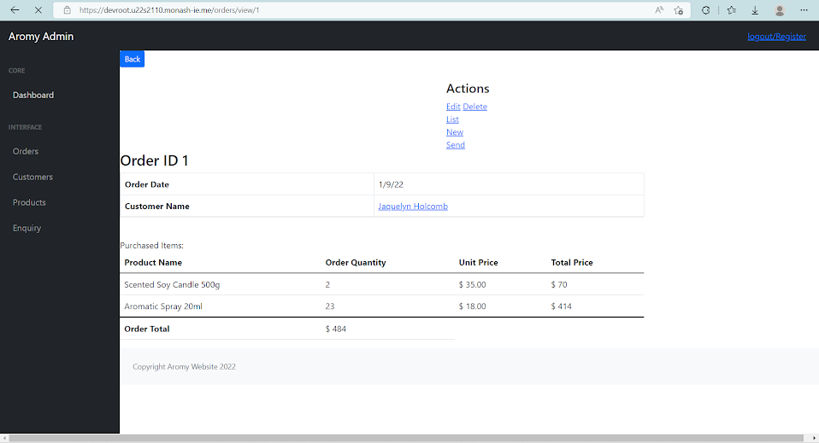

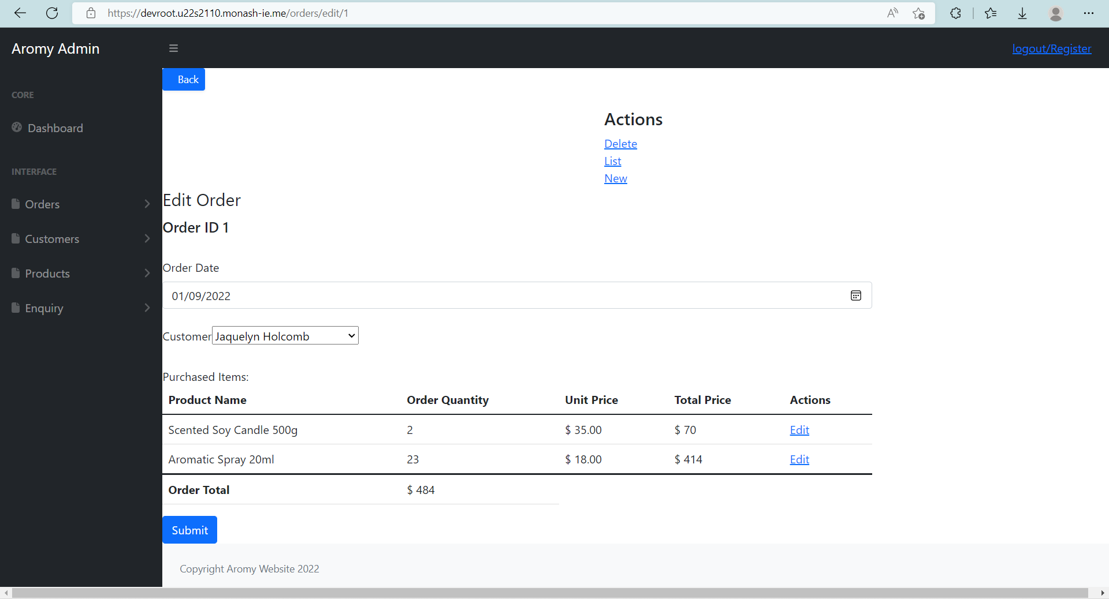

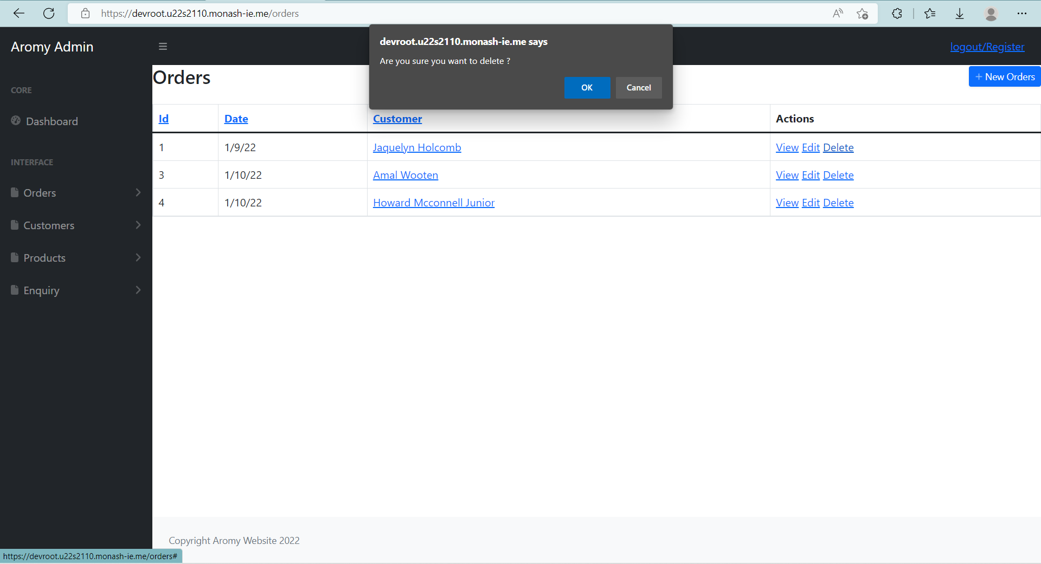

### 2.4.2.3 Add Orders

If an admin has received an enquiry and needed to add a new order, they would be able to add a new order directly through the website functionality. Below the List option on the navigation bar is the New Order option that will send you to add a new order directly into the database, using dropdowns to select products. This option is also available as a button on the top right hand side of the List view. The admin will select from existing products in the database, enter the quantity, order data and which customer is requesting an order. This will automatically calculate the prices for a product and total price for an order.

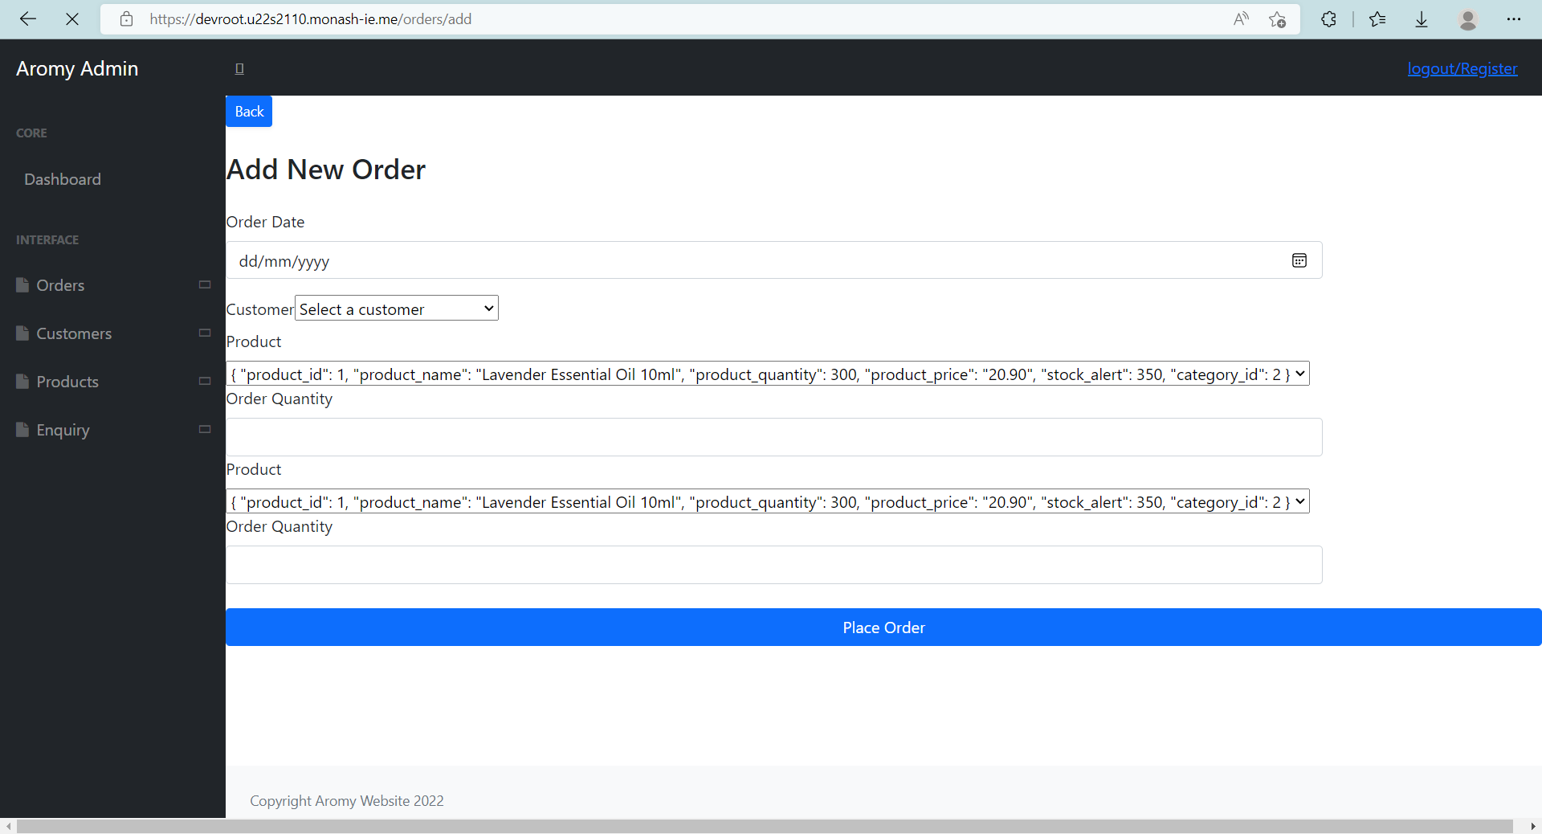

After information has been filled in, clicking submit will add the order into the database and thus will be included into the List view.

## 2.4.3 Products Management

### 2.4.3.1 Provide the List of All Products

Clicking the “Products” navigation bar on the left hand side provides the “List” option allowing you to view all products recorded in the database.

From this view, the product ID, name, quantity, price, alert quantity and category are visible at a glance.

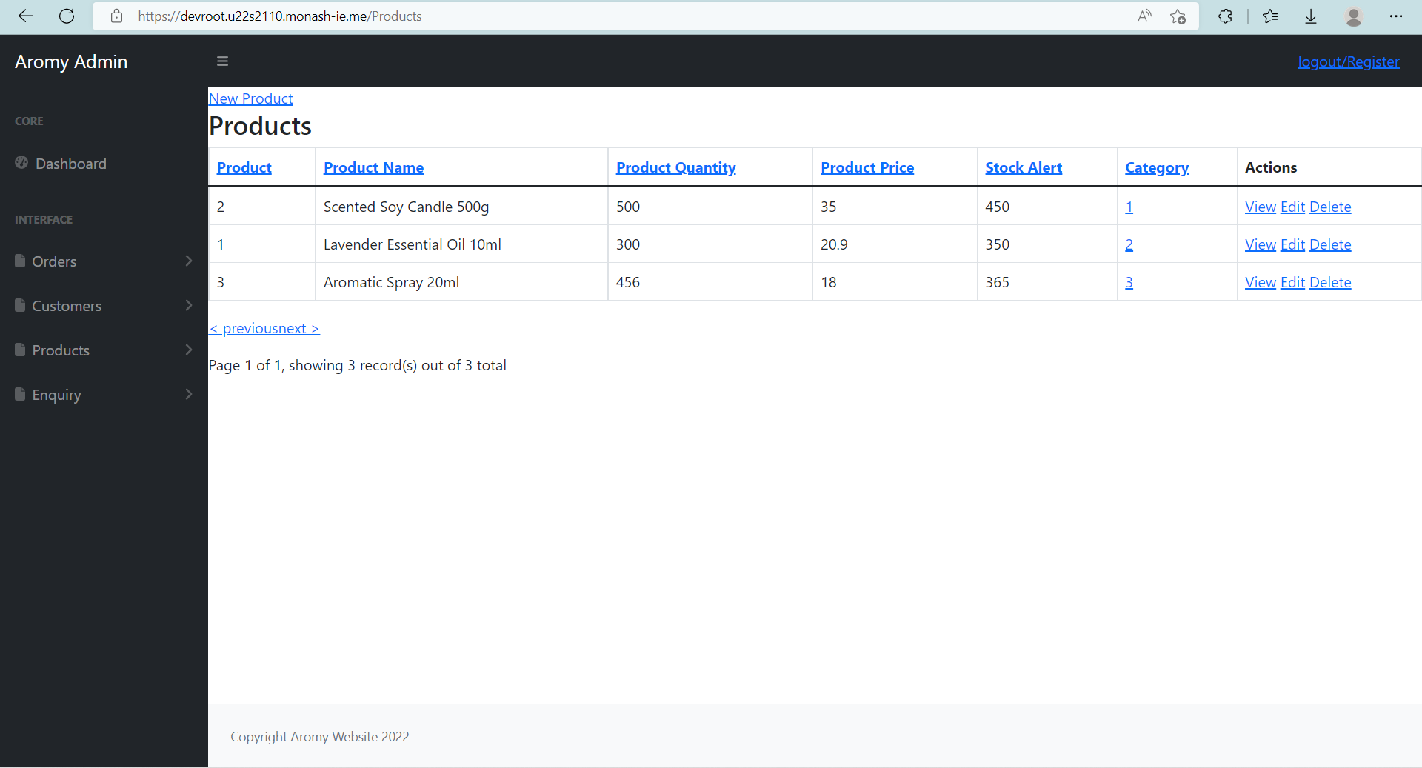

### 2.4.3.2 Use View, Edit, Delete Functions

From the **List** view under **Products**, the **View**, **Edit**, and **Delete** options are available.

The **View** option displays all details recorded about the product, same as on the list view. The **Edit** options allows a user to edit any details about a product except for the product ID. Finally, the **Delete** option will prompt the user to ensure there is no misclick and after confirming a user will be able to delete the product from the Database entirely.

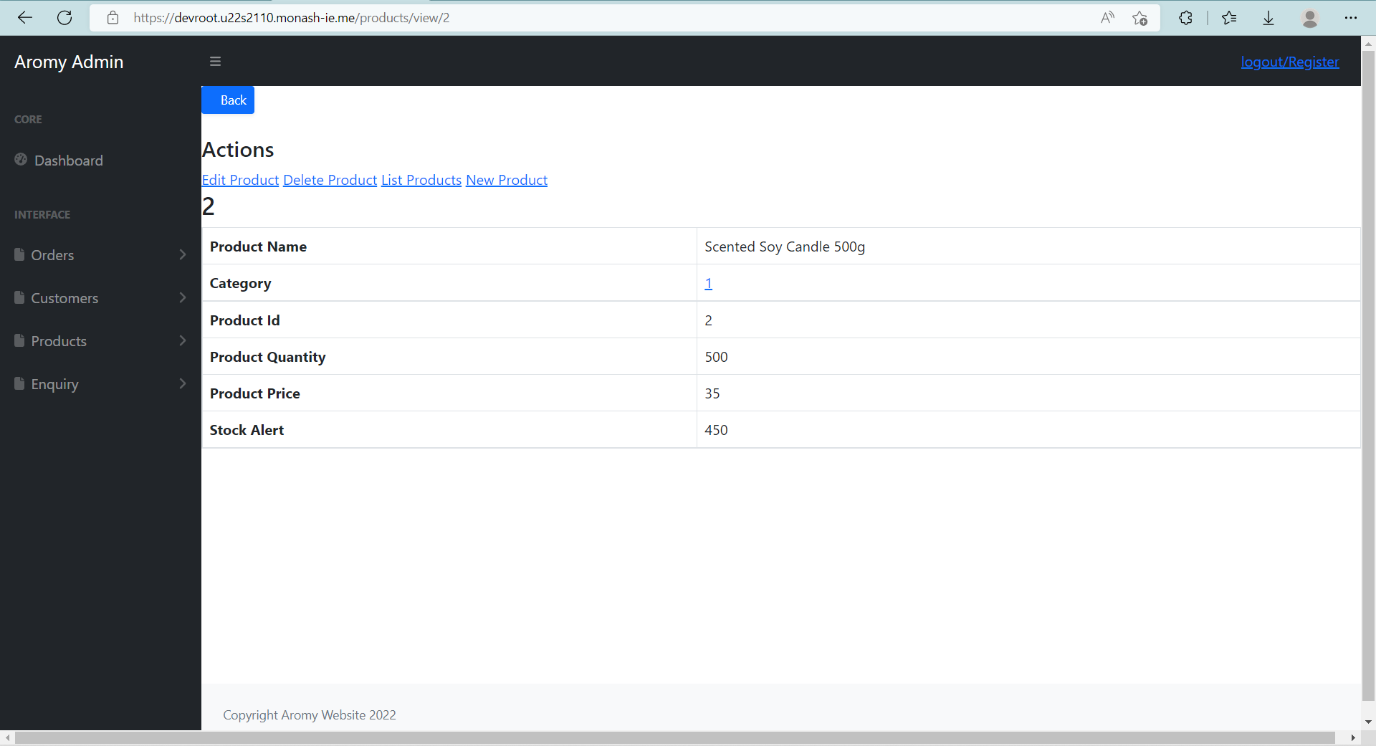

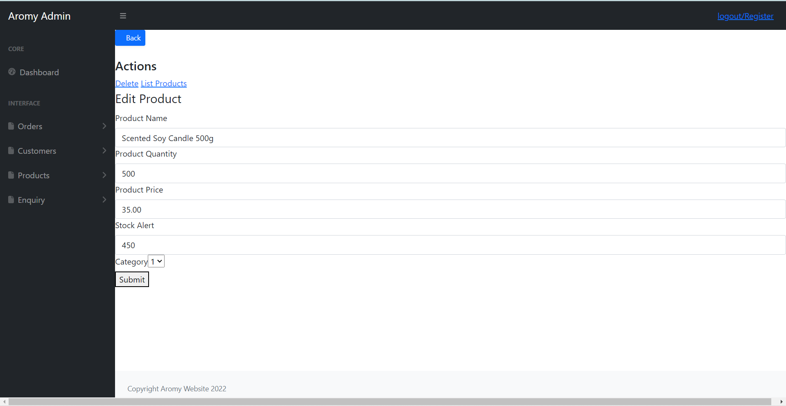

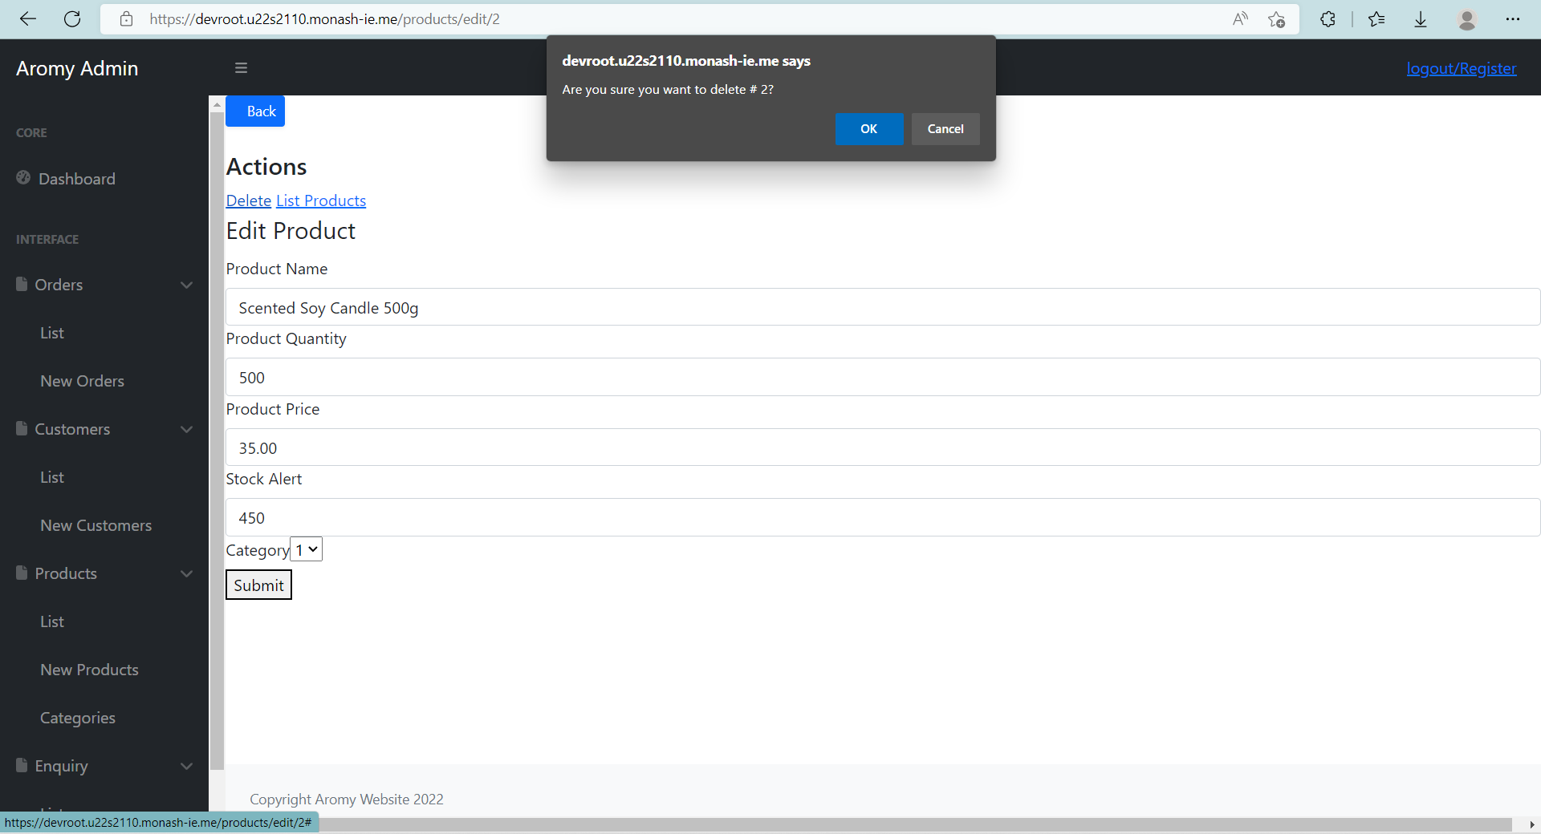

### 2.4.3.3 Add Product

Below the **List** option on the navigation bar is the **New Products** option that will send you to add a new product directly into the database, provided that all the information is present.

## 2.4.4 Categories Management

### 2.4.4.1 Provide the List of All Categories

Clicking the “Categories” navigation bar on the left hand side provides the “List” option allowing you to view all product categories used in the database.

From this view, the category number and name can be viewed at a glance.

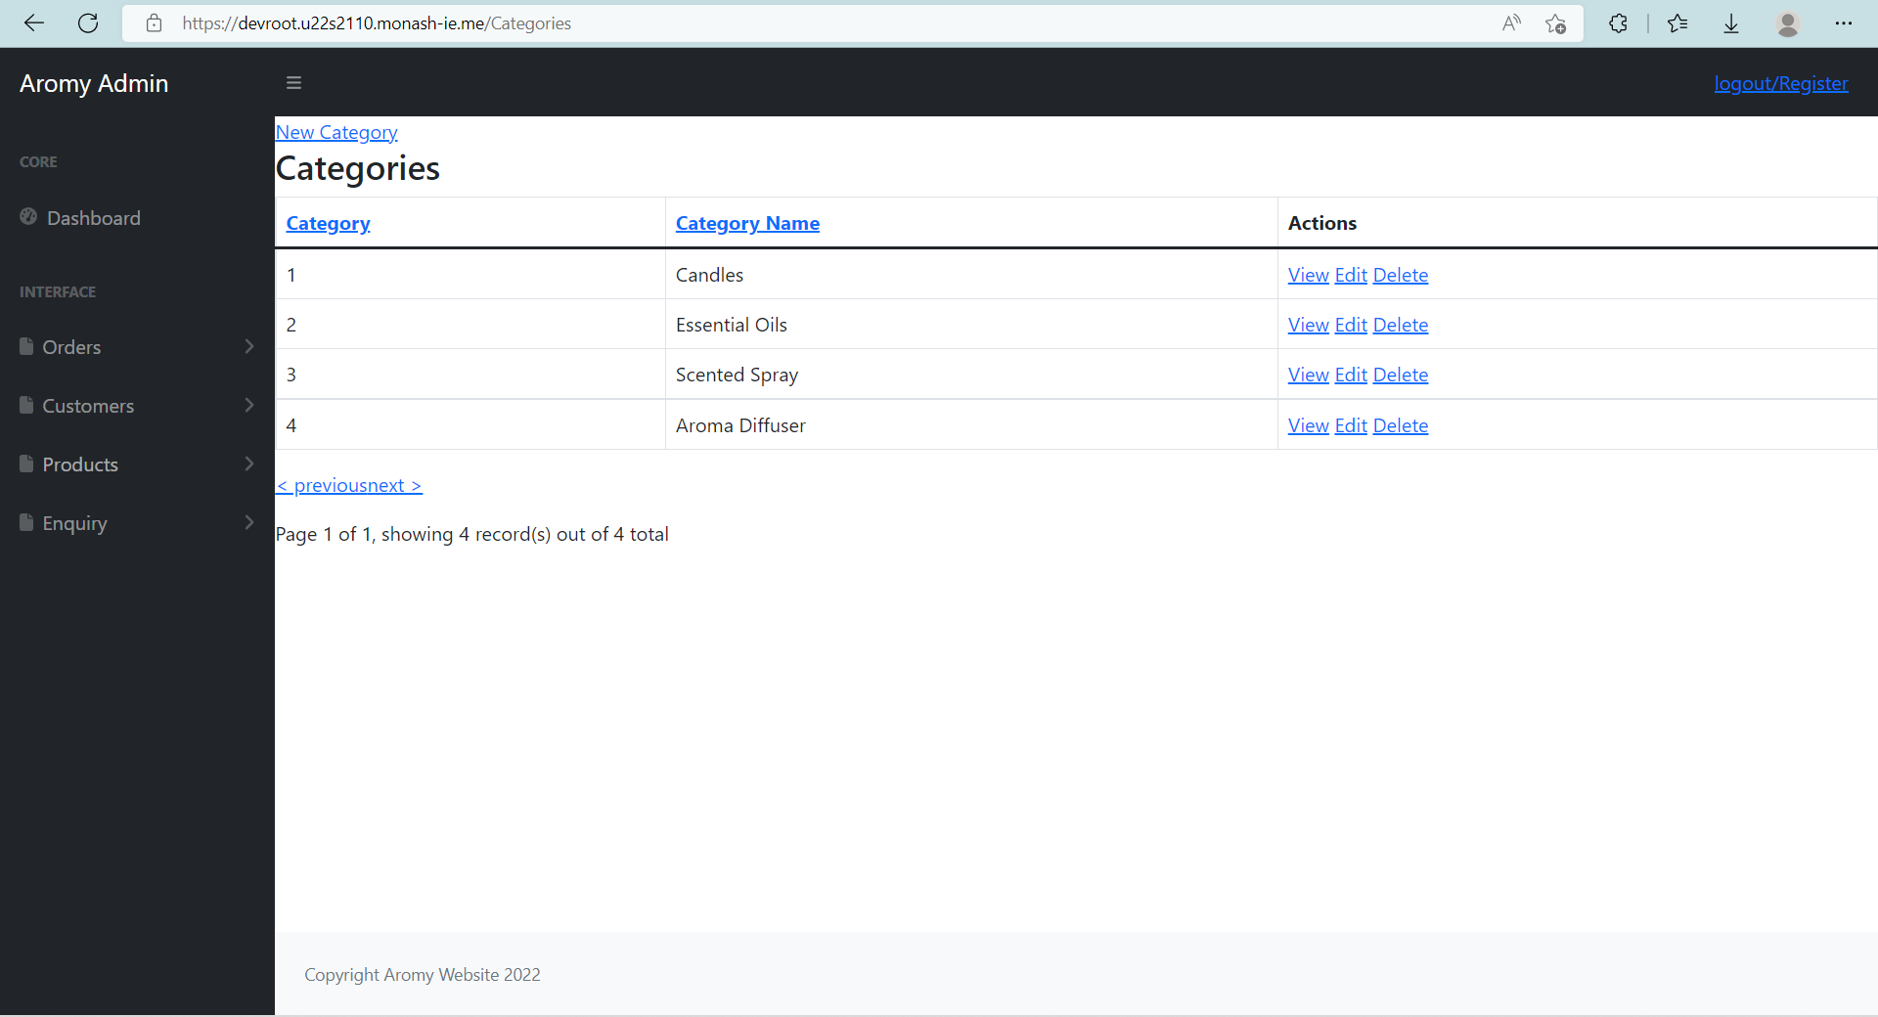

### 2.4.4.2 Use View, Edit, Delete Functions

From the **List** view under **Categories**, the **View**, **Edit**, and **Delete** options are available.

The **View** option displays all details on the category on their own page.

The **Edit** option allows a user to edit the category name.

Finally, the **Delete** option will prompt the user to ensure there is no misclick and after confirming a user will be able to delete the category from the Database

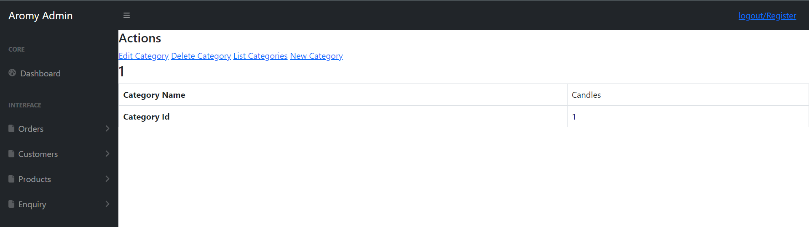

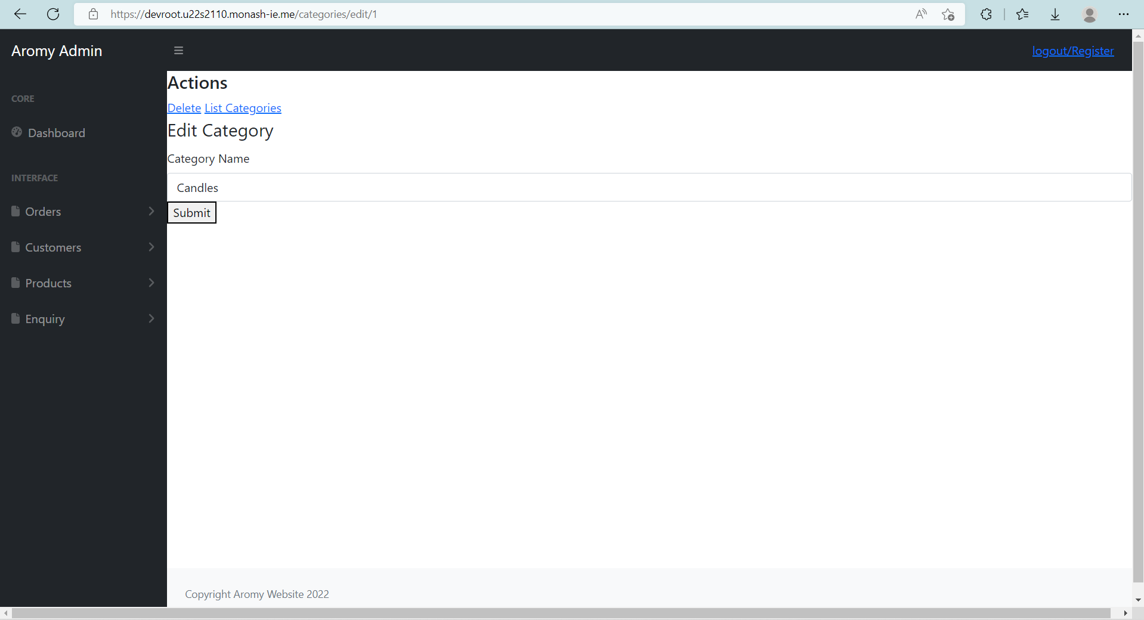.

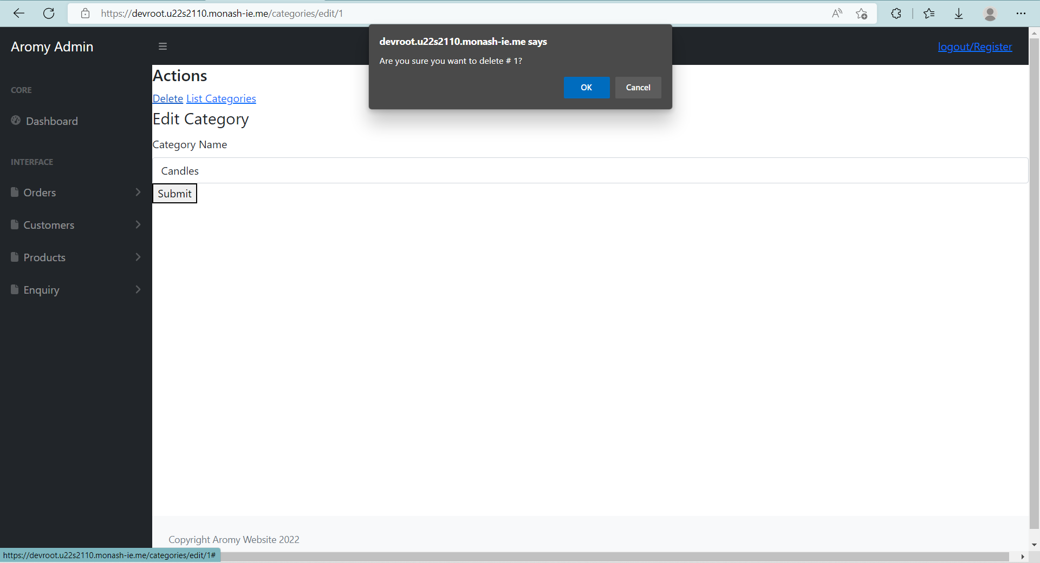

### 2.4.4.3 Add Category

Below the **List** option on the navigation bar is the **New Category** option that will send you to add a new category directly into the database.

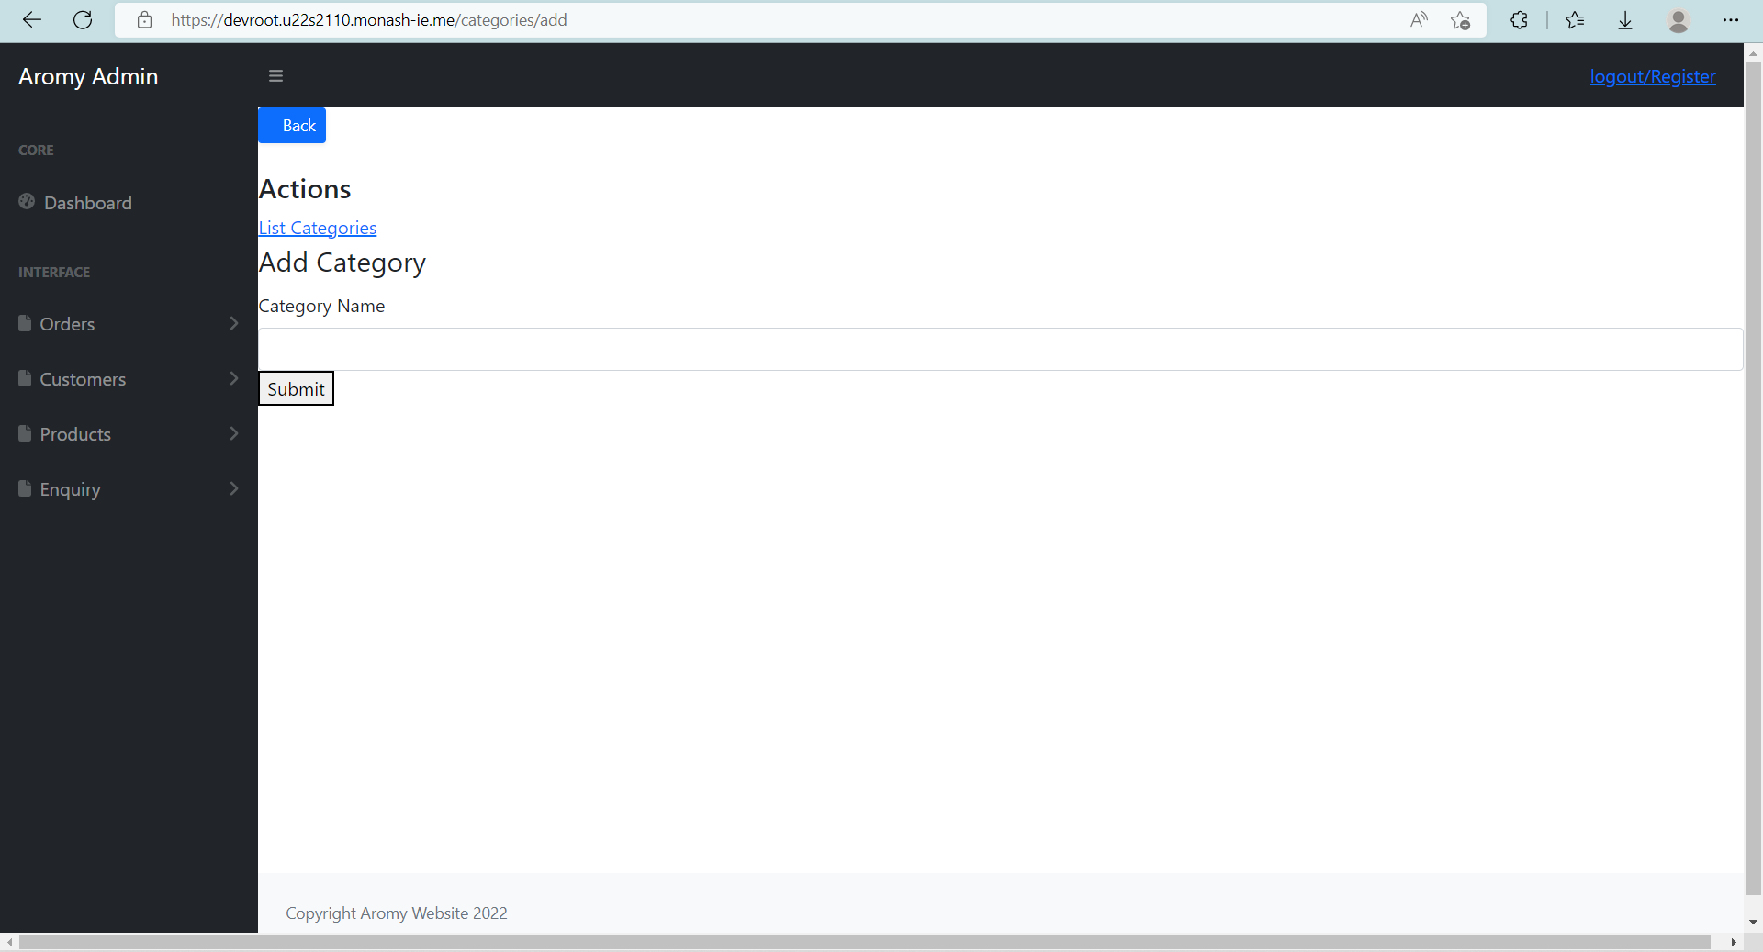

After information has been filled in, clicking submit will add the category into the database and thus will be included into the List view and allow it to be used to categorise products.

## 2.4.5 Enquiries Management

### 2.4.5.1 Provide the List of All Enquiries

Clicking the “Enquiry” navigation bar on the left hand side provides the “List” option allowing you to view all enquiries recorded in the database.

From this view, the enquiry ID, enquirer name, email address, time submitted and current numerical status.

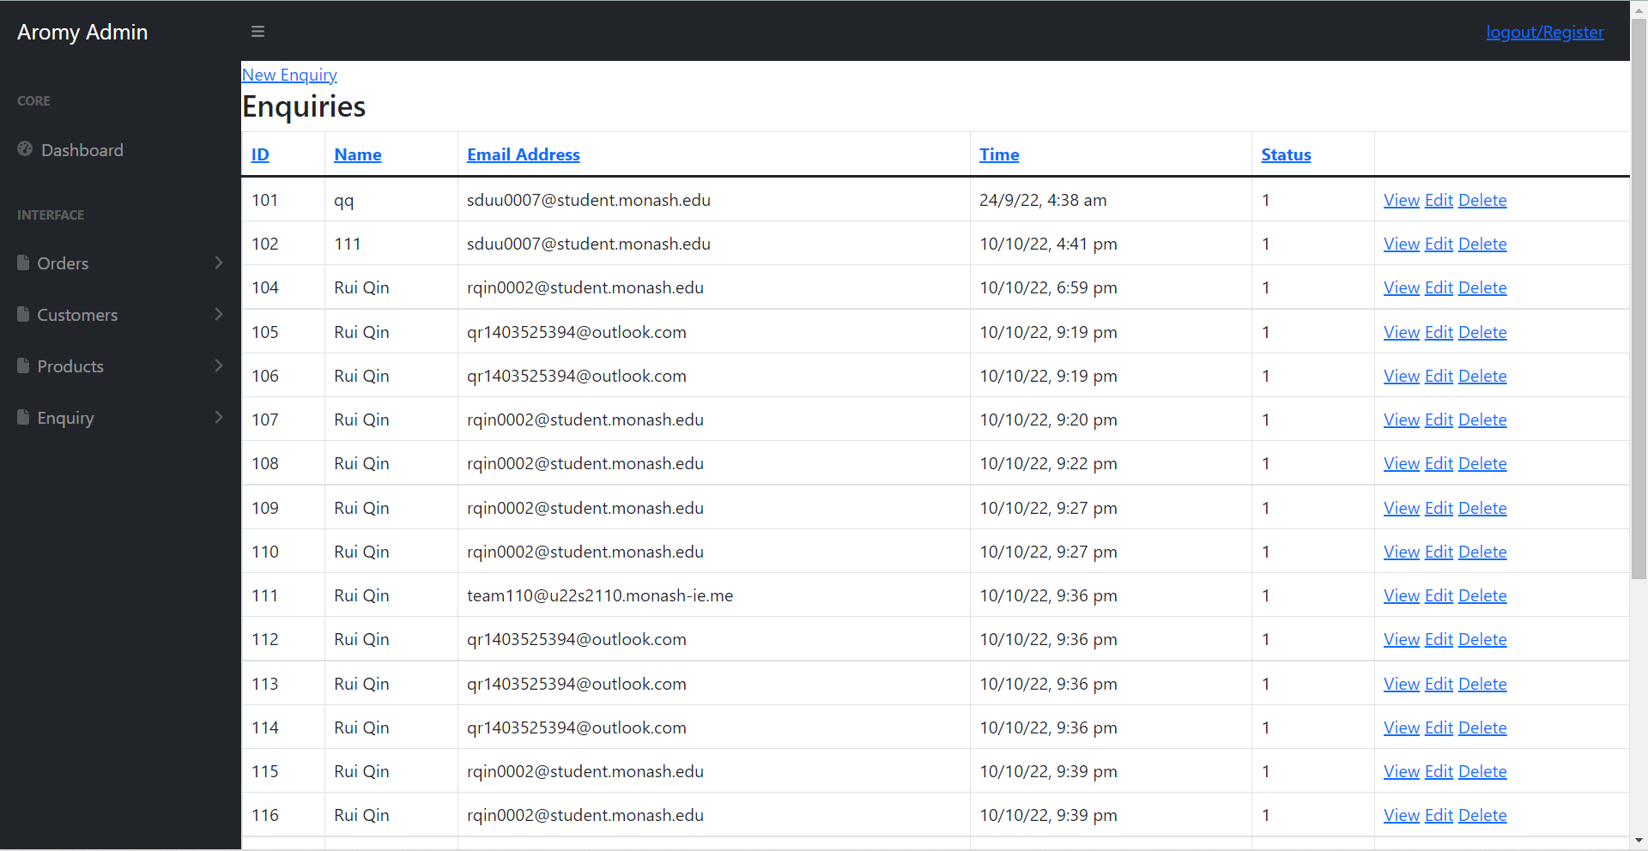

### 2.4.5.2 Use View, Edit, Delete Functions

From the **List** view under **Enquiries**, the **View**, **Edit**, and **Delete** options are available.

The **View** option displays all details about the enquiry per the List view, as well as the body of their enquiry.

The **Edit** options allows a user to edit the enquiry details and change the status.

Finally, the **Delete** option will prompt the user to ensure there is no misclick and after confirming a user will be able to delete the customer from the Database.

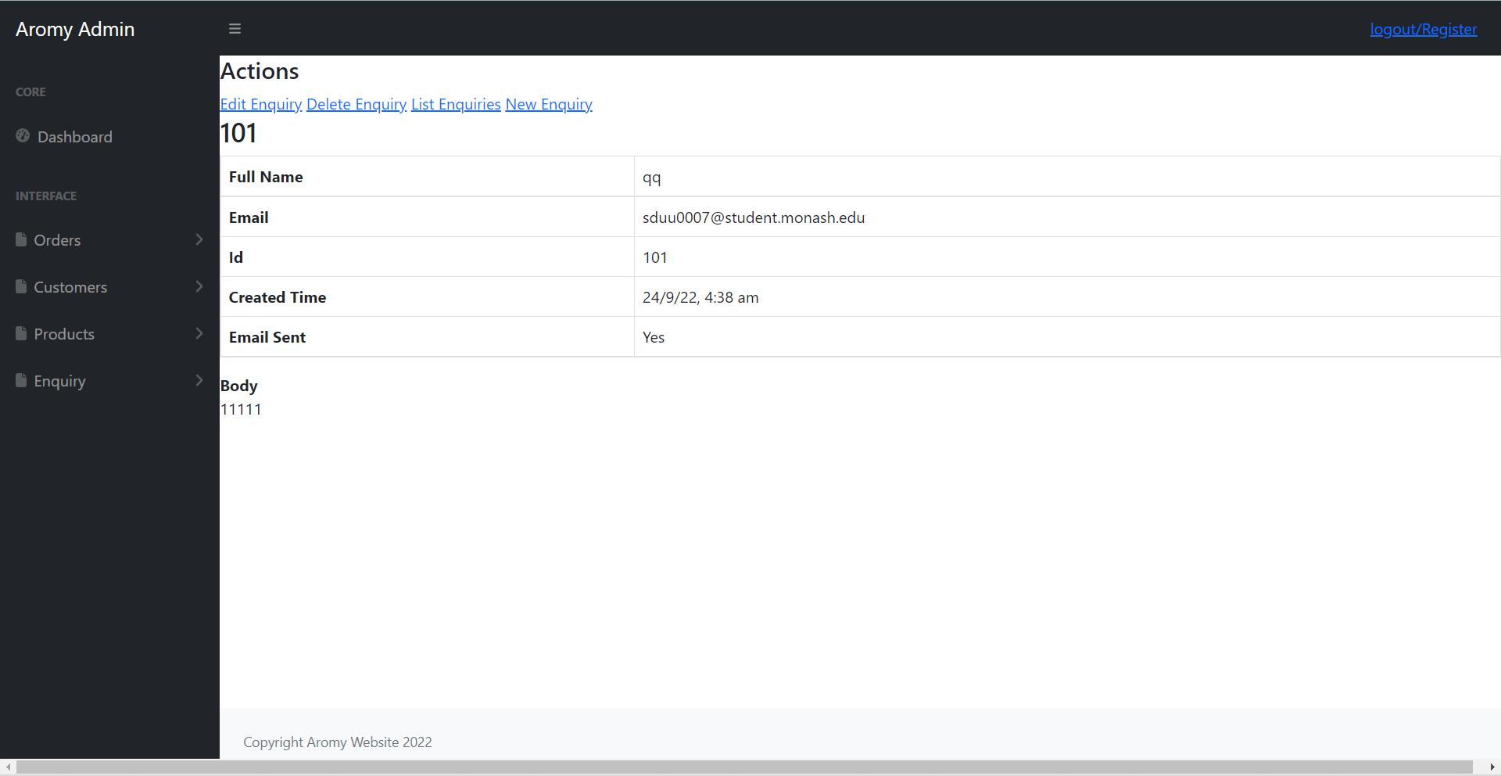

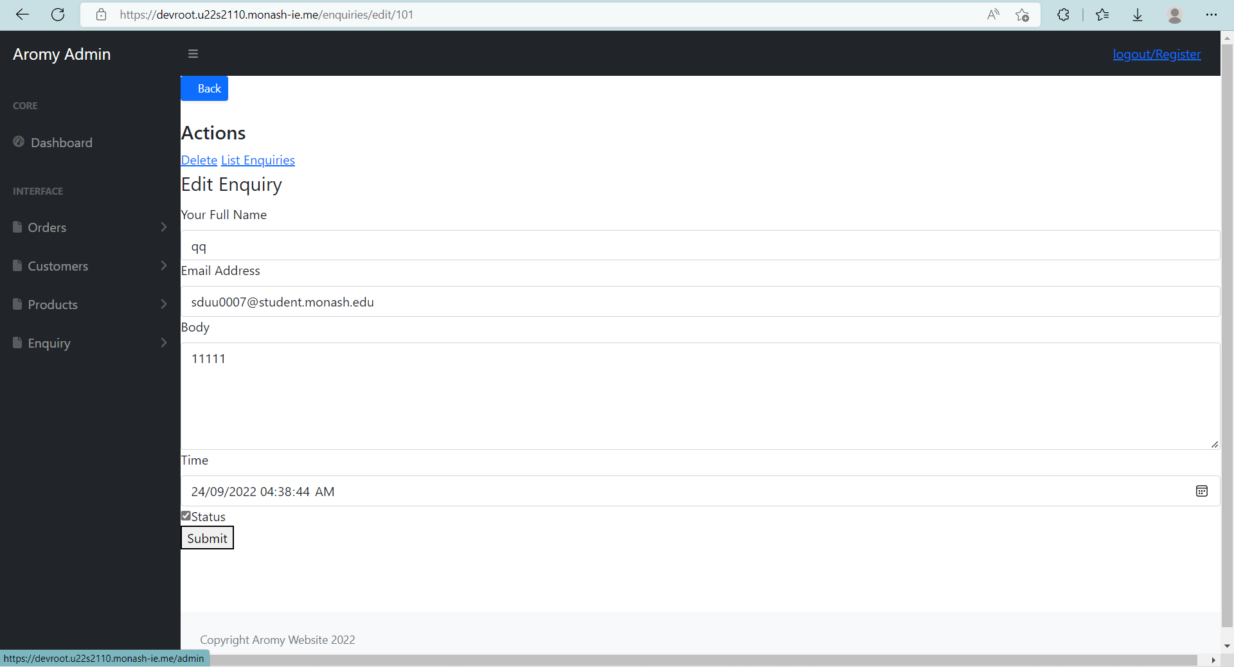

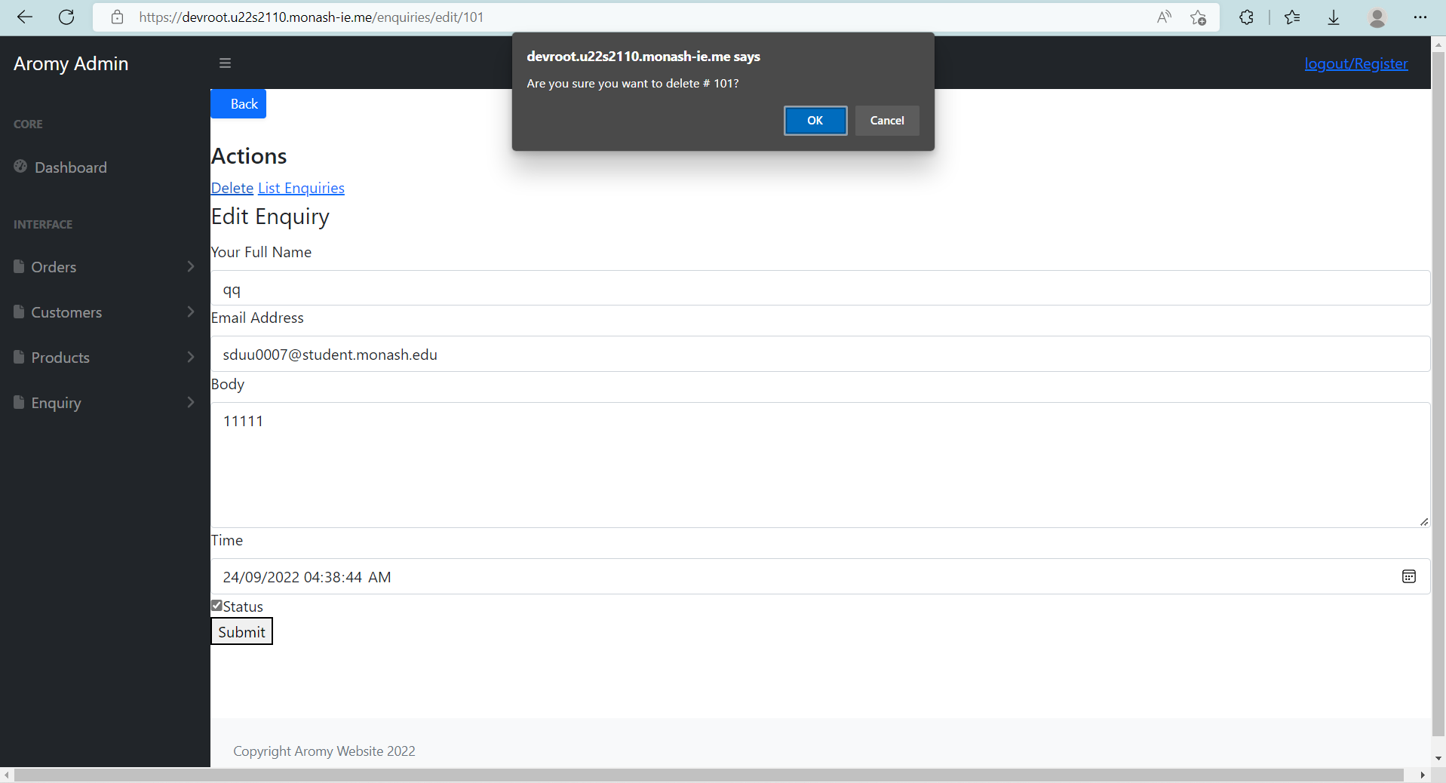

### 2.4.5.3 Add Enquiry

Below the **List** option on the navigation bar is the **New Enquiry** option that will send you to add a new enquiry directly into the database, provided that all the information is present. This links into the website enquiry lodgement form but this manual entry can be used to record an enquiry submitted from external sources (eg: mail, social media, verbal) for recording purposes.

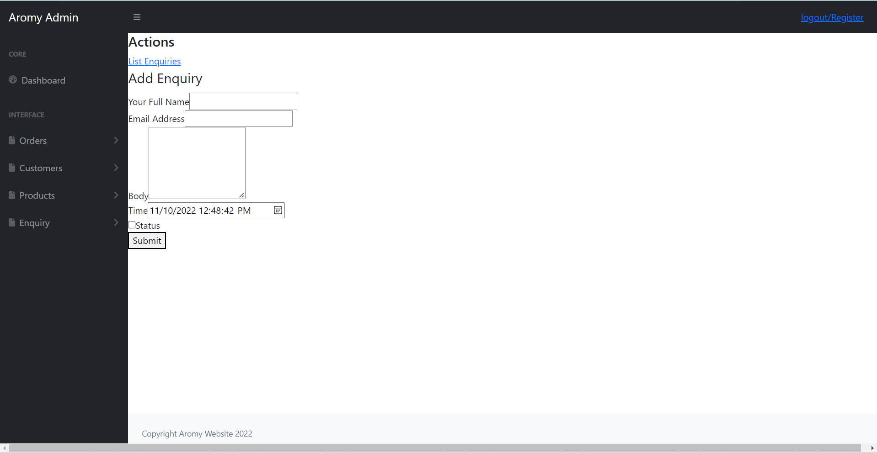

After information has been filled in, clicking submit will add the enquiry into the database and thus will be included into the List view.

## 2.4.6 User Management

### 2.4.6.1 Provide the List of All Users

From this view, the user ID and email are present.

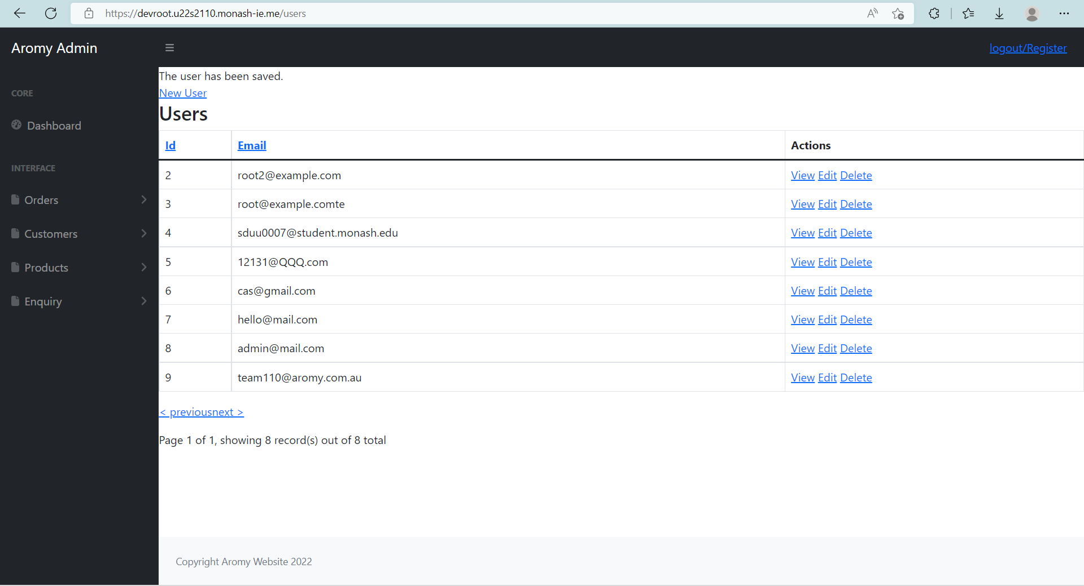

### 2.4.6.2 Use View, Edit, Delete Functions

From the **List** view under **Users**, the **View**, **Edit**, and **Delete** options are available.

The **View** option displays all details recorded about the user, including ID and email. The **Edit** options allows a user to edit the user’s email and password.

Finally, the **Delete** option will prompt the user to ensure there is no misclick and after confirming a user will be able to delete the desired user from the Database. 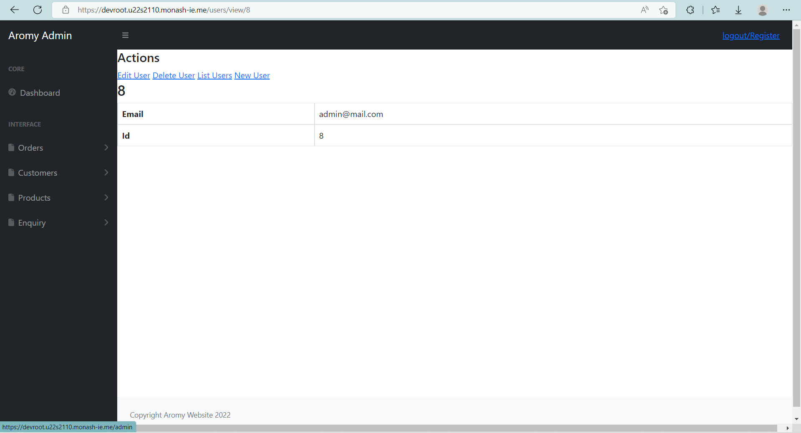

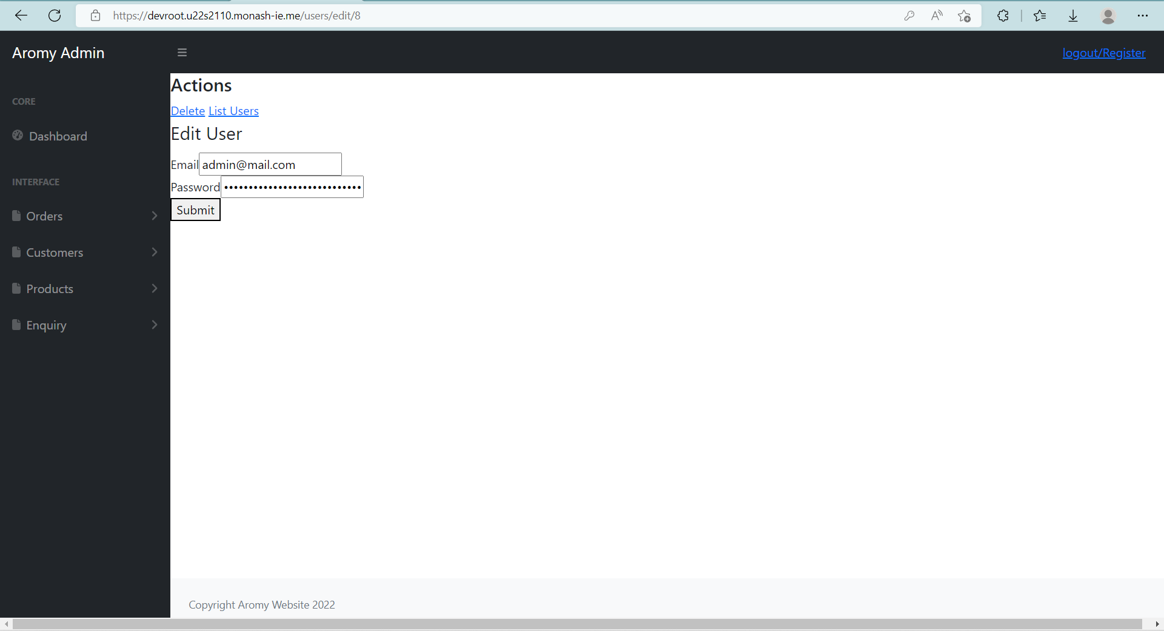

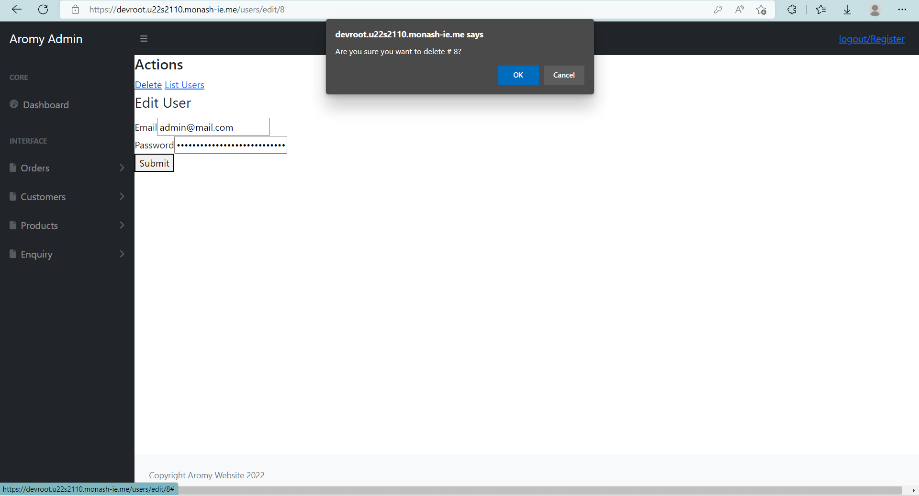

### 2.4.6.3 Add User

From the Aromy website, you can click the Account/Login link at the top to take you to the login page. From there, you will be able to click Create Account to set up a new user account.

After information has been filled in, clicking submit will add the user into the database and thus will be included into the List view.

